**Task 2**

1. Create a user account with the following attribute

• username: islam

• Fullname/comment: Islam Askar

• Password: islam

2. Create a user account with the following attribute

• Username: baduser

• Full name/comment: Bad User

• Password: baduser

3. Create a supplementary (Secondary) group called pgroup with group ID of 30000

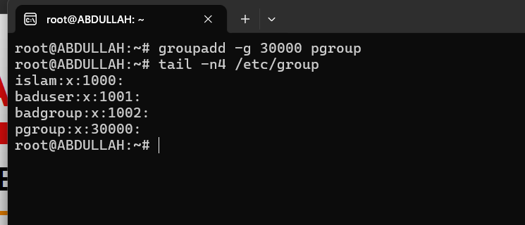

4. Create a supplementary group called badgroup

5. Add islam user to the pgroup group as a supplementary group

6. Modify the password of islam's account to *password*

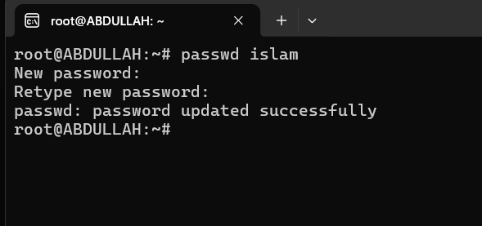

7. Modify islam's account so the password expires after 30 days



8. Lock bad user account so he can't log in

9. Delete bad user account

10. Delete the supplementary group called badgroup.

13. Create a folder called myteam in your home directory and change its permissions to read only for the owner.

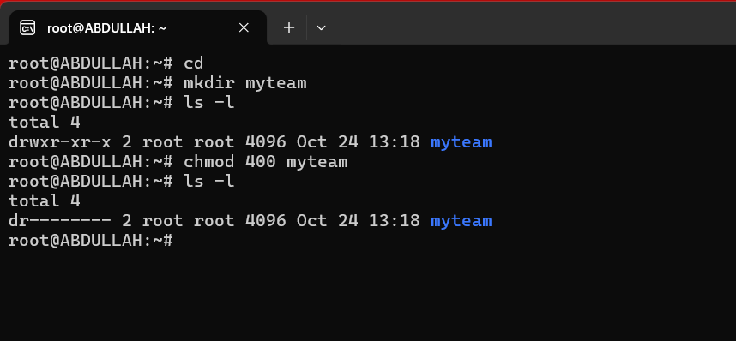

14. Log out and log in by another user

15. Try to access (by cd command) the folder (myteam)

Cannot access

16. Using the command Line

• Change the permissions of oldpasswd file to give owner read and write permissions and for group write and execute and execute only for the others (using chmod in 2 different ways)

Chmod u=rw,g=wx,o=x oldpasswd

Chmod 631 oldpasswd

• Change your default permissions to be as above.

• What is the maximum permission a file can have, by default when it is just created? And what is that for directory.

File: r and w : 666

Directory: r and w and x: 777

• Change your default permissions to be no permission to everyone then create a directory and a file to verify.

17. What are the minimum permission needed for:

• Copy a directory (permission for source directory and permissions for target parent directory)

**Source Directory Permissions**: r and x

**Target Parent Directory Permissions**: w and x

• Copy a file (permission for source file and and permission for target parent directory)

**Source Directory Permissions**: r

**Target Parent Directory Permissions**: w and x

• Delete a file

**Parent Directory Permissions**: w and x

• Change to a directory

**Permissions: x**

• List a directory content (ls command)

**Permissions: r**

• View a file content (more/cat command)

**Permissions: r**

• Modify a file content

**Permissions: w**

18. Create a file with permission 444. Try to edit in it and to remove it? Note what happened.

cannot edit the content of the file because it has read-only permissions

can delete the file

19. What is the difference between the “x” permission for a file and for a directory?

X permission for file : execute file

X permission for directory : acsses directory (cd command)